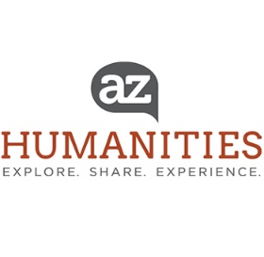

FOR IMMEDIATE RELEASE
January 15, 2020
Contact: Brenda Thomson, Executive Director / bthomson@azhumanities.org / 602-257-0335

ARIZONA HUMANITIES ANNOUNCES 2020 HUMANITIES AWARDS
Congratulations to Paul Hirt, Aguila Youth Leadership Institute, J.J. Lamb, Rosaura Magaña, Judith Hardes and Karen O’Keefe
Arizona Humanities is proud to announce the winners of the 2020 Humanities Awards. The recipients of this year’s awards are:
- Paul Hirt, Dan Shilling Public Scholar Award
- Aguila Youth Leadership Institute, Co-recipient, Juliana Yoder Friend of the Humanities Award
- J.J. Lamb, Co-recipient, Juliana Yoder Friend of the Humanities Award
- Rosaura Magaña, Humanities Rising Star Award
- Judith Hardes, Outstanding supporter award
- Karen O’keefe, Founder’s Community Partner Award
Every year we honor and celebrate outstanding contributions to the humanities in our state. Since the inaugural awards in 1990, Arizona Humanities has recognized individuals who have advanced the humanities in Arizona through their scholarship, leadership, support and advocacy. This year we are introducing a new theme: Hands-on Humanities. All of this year's winners are hands-on humanitarians, meaning they engage the community in their efforts to promote the humanities in Arizona.
Read more about each award recipient below. The 2020 Arizona Humanities Awards: Hands-on Humanities will be presented on Sunday, April 5 in the Steele Auditorium at the Heard Museum (2301 N Central Ave Phoenix, AZ 85004) from 4:30 – 7:30 p.m. Information about the event and tickets for the general public can be found at www.azhumanities.org or by calling 602-257-0335.

Paul Hirt – Dan Shilling Public Scholar award
A lifelong Arizonan, Paul Hirt is an historian and practitioner of the public and environmental humanities specializing in the American West, environmental history, environmental policy, and sustainability studies. Hirt is Professor of History in Arizona State University's School of Historical, Philosophical and Religious Studies and Senior Sustainability Scholar in ASU's Global Institute of Sustainability. He is a public historian of the American West, and an exemplary candidate for this honor.

Aguila Youth Leadership Institute - Juliana Yoder Friend of the Humanities Award
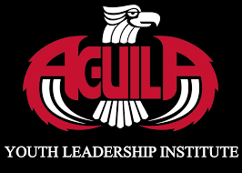

AGUILA Youth Leadership Institute (AGUILA) was founded in 2004 based on more than 30 years of research and experience on how to positively impact our communities through education. In its 15 years of operation AGUILA has successfully guided more than 1,400 youth to 135 colleges/universities across the United States with scholarships totaling more $120 million beyond federal aid. Eighty-seven percent of AGUILA students are first in their family to attend college with eighty-five percent meeting or falling below federal poverty guidelines. Many of these students receive little or no guidance on college, career and life. Today AGUILA Alumni are employed as teachers, nurses, doctors, engineers, business professionals, entrepreneurs, research scientists, and more. AGUILA student success is evident through their educational and profession achievements and through civic service.

JJ Lamb – Juliana Yoder Friend of the Humanities Award
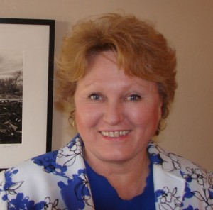
As Executive Director of the Vail Preservation Society, JJ Lamb has initiated and completed a multitude of projects that have not only preserved the history of her community, but involved an incredibly wide range of citizens. From the high school students who learned new skills working on the rehabilitation of the 1915 Marsh Station Section Foreman House to the local artists now meeting to create the Vail Connects Artist and Artisan Cooperative to the individuals whose oral histories have been preserved through the Voices of Vail and Celebrating Every Voice projects, JJ has provided access to hands-on humanities, contributing not only to her community, but to the state, and the nation beyond.

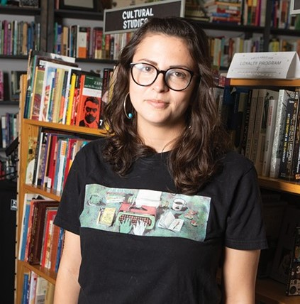
Rosaura Magaña – Humanities Rising Star Award
Rosaura "Chawa" Magaña is a bookseller, cultural worker, literary organizer, safe-space creator, healing presence, compassionate listener, principled voice, and the owner/operator of Palabras Bilingual Bookstore. Magaña has created a unique space that has shifted the cultural landscape of Phoenix to be more inclusive, equitable, and artistically enriched. Her tireless advocacy and community-centered approach has impacted many people. She has given a voice to people of color, and also fostered community connections and growth.

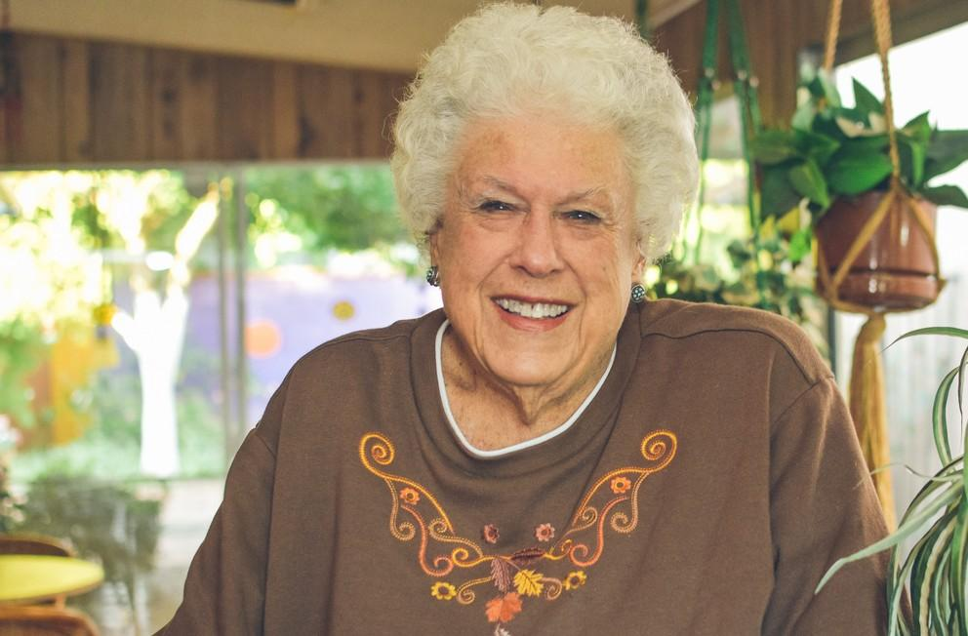
Judith Hardes – Outstanding Supporter Award
Judith Hardes is a longtime financial supporter of Arizona Humanities. She is a local philanthropist and recipient of the 2018 Governor's Arts Award for philanthropy for her lifelong commitment to arts and culture, and for her encouragement of others to give to arts and culture. Hardes has donated annually to Arizona Humanities for 20 years. She is the most consistent donor that we can identify. This means a lot to us and the organizations that receive grants and attend our cultural programs across the state. "Those who support arts and culture through their generous philanthropy are deeply vital to the long-term success and vitality of so many nonprofit organizations...Judith is among the most ardent, consistent and important donors in Arizona through her unwavering commitment to and enthusiasm for the performing arts." Rusty Foley, AZ Citizens for the Arts.

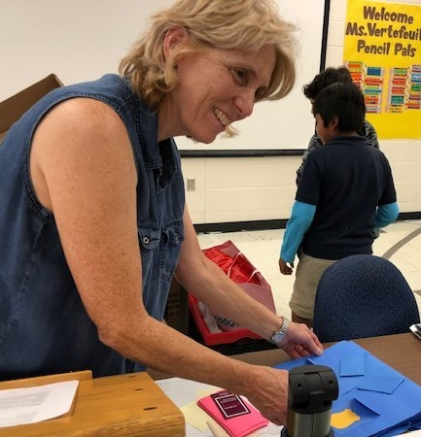

Karen O’keefe – Founder’s Community Partner

Karen O'Keefe is an outstanding educator with a focus on K-12 literacy, and a unique passion for connecting students to the community through her extensive outreach efforts. O'Keefe seeks out people in the community to support the literacy programs including retired and working individuals, illustrators, artists, authors, and even family members of the students. She also enlists the support of countless community-based, nonprofit and corporate organizations. O'keefe's community-based events both inside and outside the school, have recast the importance of literacy for the entire school. She is the recipient of many awards of excellence from the Washington School District for her innovative/interactive learning programs including PencilPALS, Multi-Cultural Day, Young Authors Day, Family Reading Nights, and Read Across America Day.

12 N. Central Avenue, Phoenix, AZ 85004 │ 602-257-0335 │info@azhumanities.org │ 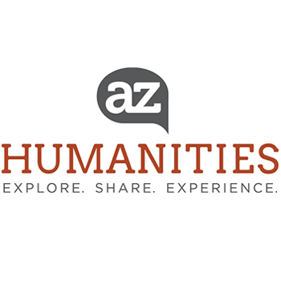 www.azhumanities.org

Arizona Humanities
http://www.azhumanities.org
Mission: Arizona Humanities builds a just and civil society by creating opportunities to explore our shared human experiences through discussion, learning and reflection. Arizona Humanities is a statewide 501(c)3 non-profit organization and the Arizona affiliate of the National Endowment for the Humanities. Since 1973, Arizona Humanities has supported public programs that promote understanding of the human experience with cultural, educational, and non-profit organizations across Arizona.

