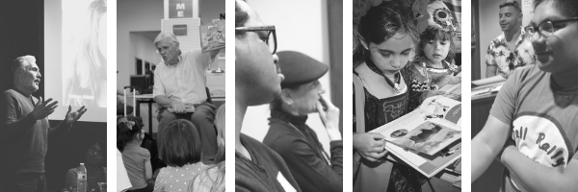

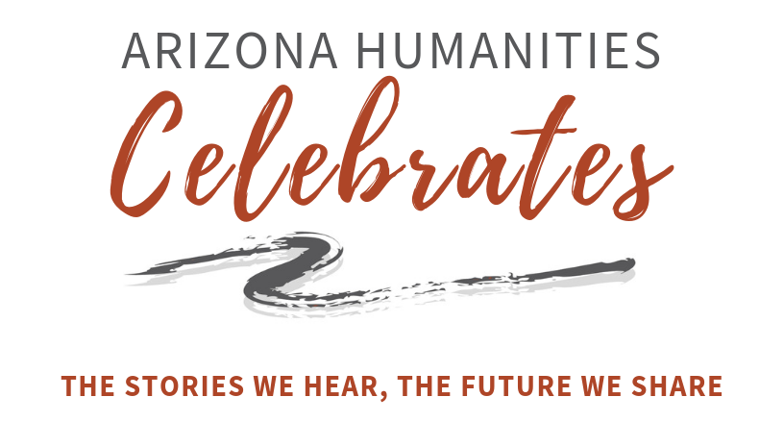
Awards Sponsorship Packet 2020

Sunday, April 5, 2020
5:30 – 8:30 p.m.
Heard Museum – Steele Auditorium
2301 N Central Ave, Phoenix, AZ 85004

Our Mission

Arizona Humanities builds a just and civil society by creating opportunities to explore our shared human experiences through discussion, learning and reflection.

Arizona Humanities Celebrates…the Humanities Awards

For more than 25 years, Arizona Humanities has honored and celebrated outstanding contributions to the humanities in our state by recognizing individuals and community organizations who have advanced the humanities in Arizona through their scholarship, leadership, support, and advocacy. We are delighted to honor this year's award recipients and are especially pleased to highlight two special community partners. The award recipients below help us bring the rich cultural history of Arizona to communities everywhere. We hope you will support this festive event and join us in celebrating the work of the award recipients and Arizona Humanities. Your sponsorship creates opportunities for Arizonans to explore our history, culture, and stories.

2020 Award Winners

Paul Hirt – Humanities Public Scholar
Rosaura Magaña – Humanities Rising Star
J.J. Lamb - Friend of the Humanities
Aguila Youth Leadership Institute – Friend of the Humanities
Judith Hardes – Community Partner Outstanding Supporter Award
Karen O’Keefe – Founder’s Community Partnership Award

Event Information

Sunday, April 5, 2020
5:30 – 8:30 p.m.
Heard Museum – Steele Auditorium
2301 N Central Ave, Phoenix, AZ 85004

Tickets

$50 per person
Hosted refreshments and entertainment
To purchase tickets visit: https://azhumanities.org/2019-arizona-humanities-awards/

Sponsorship Contact

Brenda Thomson, Executive Director
bthomson@azhumanities.org
602-257-0335 x22
Sponsorship Levels
Premier Sponsor
$5,000

- Recognition as Premier Sponsor
- Recognition in all promotional materials
- Banner recognition at the Awards Event
- Full-page ad space in event program
- 10 tickets to Humanities Awards Event
- 6 Reserved Seats to Natasha Trethewey VIP Reception on April 25, 2019

Featured Sponsor
$2,500

- Recognition as Featured Sponsor
- Recognition in all promotional materials
- Banner recognition at the Awards Event
- Half-page ad space in event program
- 8 tickets to Humanities Awards Event

Contributing Sponsor
$1,000

- Recognition as Contributing Sponsor
- Recognition in all promotional materials
- Logo or individual name in event program
- 4 tickets to Humanities Awards Event
Public Humanities Scholars – Dan Shilling Award
This award recognizes humanities scholars who have distinguished themselves by enhancing public understanding of the role the humanities play in transforming lives and strengthening communities, and have been recognized leaders in promoting the humanities.

Paul Hirt
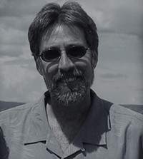
A lifelong Arizonan, Professor Paul Hirt is an historian and practitioner of the public and environmental humanities specializing in the American West, environmental history, environmental policy, and sustainability studies. Hirt is Professor of History in Arizona State University's School of Historical, Philosophical and Religious Studies, is a Senior Sustainability Scholar in ASU's Global Institute of Sustainability. Professor Hirt is a quintessential practitioner of the public humanities: his work is intended for a broad audience and seeks to contribute substantively to debates over public policy and the stewardship of Arizona's public resources. A tireless public advocate of the humanities and their
relevance for the Arizona public, Hirt regularly gives presentations about water resources, renewable energy, electric vehicles, and more across the state to civic organizations, student groups, retirement communities, and on the Navajo Nation.

Humanities Public Scholar Nominees
Demion Clinco, Rosemarie Dombrowski, Betsy Fahlman, Björn Krondorfer, Bertha Manninen

Humanities Rising Star Award
This award recognizes a young professional, student, or volunteer with outstanding creative approaches to engaging the public with the humanities, and whose humanities scholarship and public service has enhanced public understanding of the humanities.

Rosaura Magaña

Rosaura "Chawa" Magaña is a cultural worker, literary organizer, safe-space creator, healing presence, compassionate listener, principled voice, and the owner/operator of Palabras Bilingual Bookstore. Magaña has created a unique space that has shifted the cultural landscape of Phoenix to be more inclusive, equitable, and artistically enriched. Besides providing a much needed space for Spanish speakers to seek literary works in their language, Magaña has created her monthly "POC It To Me" open mic to center the local voices of people of color. She has also established a book club for women, developed a bi-weekly writing group for women of color, and has invited other organizations to host writing groups, such us Trans Queer Pueblo's "Creatures of Our Dreams." Her tireless advocacy and community-centered approach has impacted many people. She has given a voice to people of color, and also fostered community connections and growth.

Humanities Rising Star Nominees
Lizbette Benge, Seth Schermerhorn, Jake Friedman and Kelsey Pinckney, J. Seth Schermerhorn

Friend of the Humanities – Juliana Yoder Award
This award recognizes individuals who have made a lasting contribution to the cultural life of their communities through their active support of and involvement in promoting the humanities. The award recognizes the dedication and contribution of Julian Yoder during her service and leadership with Arizona Humanities.

Co-recipient - AGUILA Youth Leadership Institute
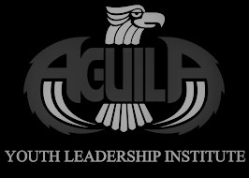
AGUILA Youth Leadership Institute (AGUILA) was founded in 2004 based on more than 30 years of research and experience on how to positively impact communities through education. During the past 15 years AGUILA has successfully guided more than 1,400 youth to 135 colleges/universities across the United States, with scholarships totaling more than $120 million beyond federal aid. Eighty-seven percent of AGUILA students are the first person in their family to attend college. Eighty-five percent of students meet or fall below federal poverty guidelines. Many AGUILA students received little or no guidance on college, career and life before joining the program. Today AGUILA Alumni are employed as teachers, nurses, doctors, engineers, lawyers, business professionals, entrepreneurs, research scientists, and more. AGUILA student success is evident through not only their educational and professional achievements, but also through civic service.

Co-recipient - J.J. Lamb
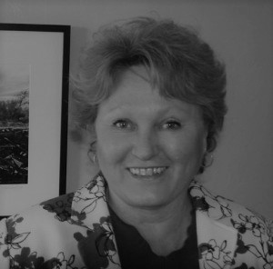
As Executive Director of the Vail Preservation Society, JJ Lamb has led a multitude of projects that have not only preserved the history of her community, but also involved a wide range of citizens. High school students learned new skills working on the rehabilitation of the 1915 Marsh Station Section Foreman House. Local artists have created the Vail Connects Artist and Artisan Cooperative. Many local individuals have shared their oral histories, now preserved through the Voices of Vail and Celebrating Every Voice projects. Lamb's work has contributed to her community, the state and the nation beyond.

Friend of the Humanities Nominees
Marc Ashton, Paul Friedman, John Liffiton, Tyler Meier

Community Partner Outstanding Supporter Award
Judith Hardes
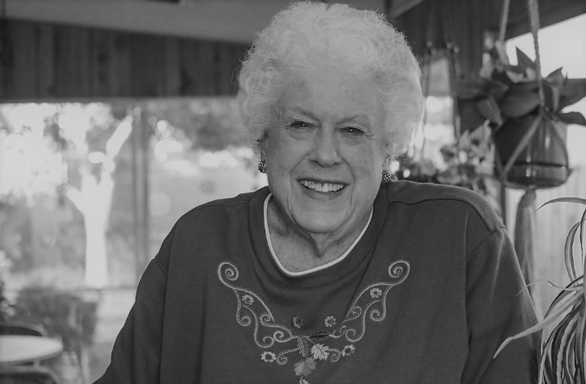
Judith Hardes is a longtime financial supporter of Arizona Humanities and of arts and culture in Arizona. Hardes is a local philanthropist and recipient of the 2018 Governor's Arts Award for philanthropy for her lifelong commitment to arts and culture, and for her encouragement of others to give to arts and culture. Hardes has donated annually to Arizona Humanities for 20 years. She is the most consistent donor that we can identify. This means a lot to us and the organizations that receive grants and attend our cultural programs across the state. "Those who support arts and culture through their generous philanthropy are deeply vital to the long-term success and vitality of so many nonprofit organizations...Judith is among the most ardent, consistent and important donors in Arizona through her unwavering commitment to and enthusiasm for the performing arts." Rusty Foley, AZ Citizens for the Arts.

Founder’s Community Partner Award
Karen O’Keefe
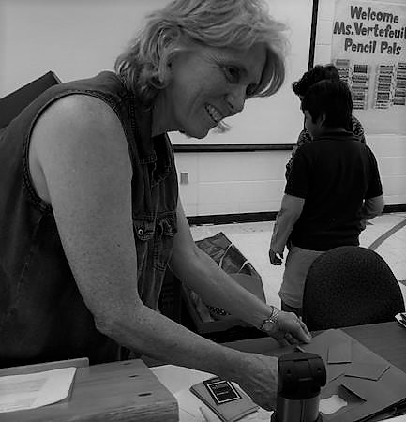
Karen O'Keefe is an outstanding educator with a focus on K-12 literacy, and a unique passion for connecting students to the community through her extensive outreach efforts. O'Keefe seeks out people in the community to support literacy programs including retired and working individuals, illustrators, artists, authors, and even family members of the students. She also enlists the support of countless community-based, nonprofit and corporate organizations. O'Keefe's community-based events both inside and outside the school, have recast the importance of literacy for Mountain View School. She is the recipient of many awards of excellence from the Washington School District for her innovative/interactive learning programs including PencilPALS, Multi-Cultural Day, Young Authors Day, Family Reading Nights, and Read Across America Day.

Past Awards Recipients

Humanities Public Humanities Scholar Award

2019 – Natalie Diaz
2019 – Joan McGregor
2018 – Liz Warren
2017 – James Blasingame
2015 – Alberto Álvaro Ríos
2015 – Dr. Paul Espinosa
2014 – Dr. David William Foster
2013 – Dr. Gloria H. Cuádraz
2012 – Nancy Dallet
2012 – Elena Diaz Bjorkquist
2010 – Celestino Fernández
2009 – Charles Tatum
2007 – Karen J. Leong
2006 – Laura Tohe
2005 – Matthew Whitaker
2004 – Mary Melcher
2003 – Judy Nolte Temple
2002 – Elizabeth Larson-Keagy
2001 – Neal A. Lester
2000 – Patricia Preciado Martin
1999 – Peter Iverson
1998 – L. Chris Smith
1996 – Joann Kealiinohomoku
1995 – Christine Marin
1994 – Jay Cravath
1993 – Robert Trennert
1992 – James Griffith
1991 – Mary L. Rothschild
1990 – James Byrkit

Friend of the Humanities Award

2019 – Kevin Schindler
2018 – Almira Poudrier
2017 – Barbara Hatch
2015 – Dr. Michael Vincent
2014 – Project Humanities
2013 – Gail Browne
2013 – Tucson Historic Preservation Foundation
2012 – Arizona Town Hall
2010 – William Fry
2009 – Winifred Bundy, Singing Wind Bookshop
2007 – Changing Hands Bookstore
2006 – Arizona Office of Tourism
2005 – James R. Carruthers
2004 – Noel Stowe
2003 – KAET-TV, Channel 8
2002 – Salt River Project
2001 – Arizona State Library, Archives & Public Records
2000 – The Arizona Republic and Jack W. Whiteman (posthumous award)
1999 – Arizona State Representative Carolyn Allen and United States Congressman Jim Kolbe
1998 – Elsa Paine Mulher

Humanities Rising Star Award

2019 – Rachel Egboro
2018 – Dagoberto Bailon
2017 – Nancy Godoy-Powell
2015 – Rivka Rocchio
2014 – Tyler Wayne Vertrees
2013 – Myrlin Hepworth
2013 – Jaclyn Roessel

Distinguished Organizations Award

2007 – Pima County Library
2006 – Phoenix Burton Barr Central Library
2005 – Museum Association of Arizona
2004 – Sharlot Hall Museum, Prescott
2003 – Hassayampa Institute for Creative Writing at Yavapai College
2002 – Center for Desert Archaeology, Tucson
2001 – Historic Sahuaro Ranch Foundation, Glendale
2000 – Parker Public Library
1999 – Arizona Historical Society, Southern Arizona Division
1998 – Scottsdale Cultural Council
1996 – Bisbee Mining & Historical Museum
1995 – Arizona State Museum
1994 – The Heard Museum
1993 – Yuma County Library District
1992 – Mohave Museum of History and Arts
1991 – Casa Grande Valley Historical Society Museum
1990 – Glendale Public Library, Apache Junction Public Library (co-recipients)

Community Partner Outstanding Supporter Award
2019 – Rodo Sofranac
2018 – The Shackelford Family

Founder’s Community Partner Award
2019 – Morning Star Leaders, Inc. Megan LaRose, Debbie Nez-Manuel, Royce Manuel
2018 – Arizona State Library, Archives and Public Records

